***Term Documentation Project***

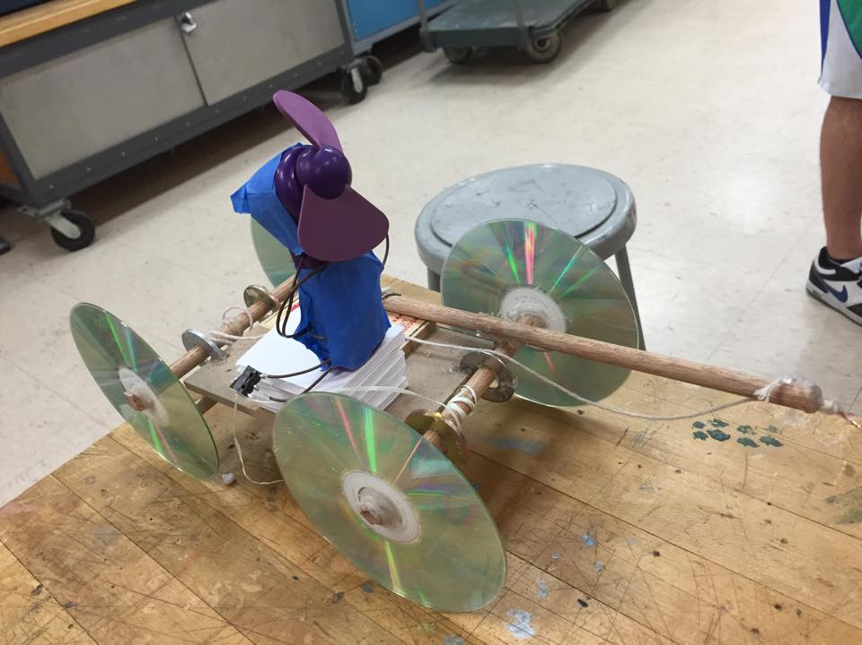

*Team Members:*

*Mike Candiano*

*Jamie Lee*

*John Kaplan and Bryan Guner*

The Design Process 1.

**Table of Contents**

(Bryan Guner)

Building the Robot 6.

(Jamie Lee)

Reconstruction 8.

(Jon Kaplan)

Wiring and The Finished Product 11.

(Mike Candiano)

Fire Extinguishing Robot Documentation Report

Bryan Guner

(Design)

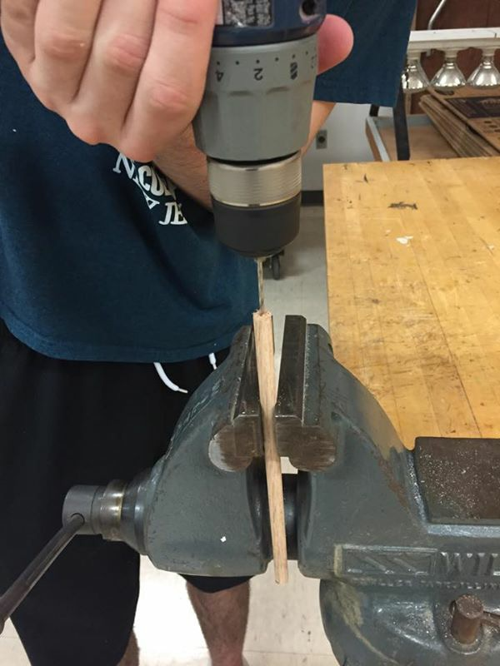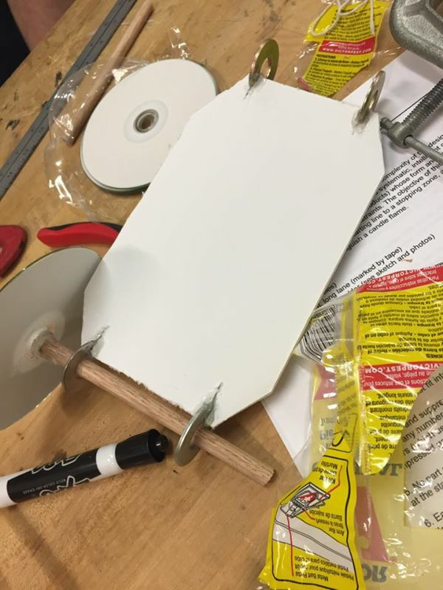 Our Fire Extinguishing robot was designed based on the “mouse trap car” framework. This configuration uses the stored energy in a mousetrap, to propel our robot forward a fixed distance before triggering a fan(Calibre) to extinguish a candle flame. This robot, in essence, is simply a platform on wheels that has a mousetrap (Victor) mounted on top with an extended lever arm (to reduce mechanical advantage). The lever arm is attached to a string (Cirrus Twine), which is curled around one of the axles made out of a wooden dowel (Home Depot), such that when the mousetrap is released the lever arm causes the axle to spin. The other axle was connected by a specific length of string to the fan’s switch, so that when the robot had traveled 10 feet, the switch would be pulled, activating the fan and stopping the car simultaneously. Pictures of the construction can be seen below in figures 1-4.

Baseboard with one imcomplete axle about to be mounted (figure 1)

Figure 2: (Lever arm being drilled in preparation for attachment to mousetrap)

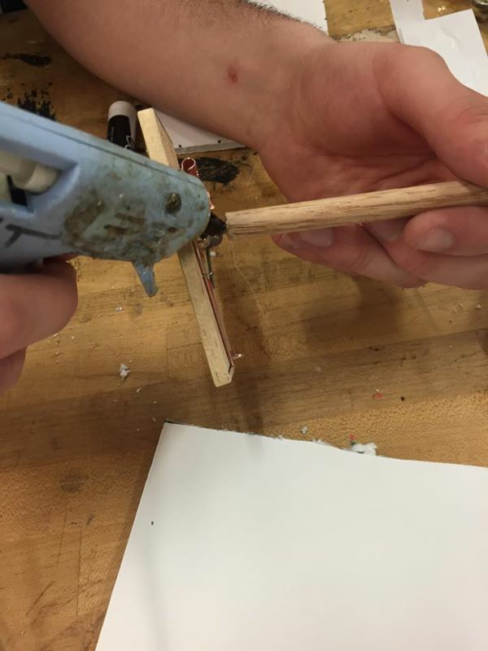

Attaching lever arm to mousetrap (figure 3)

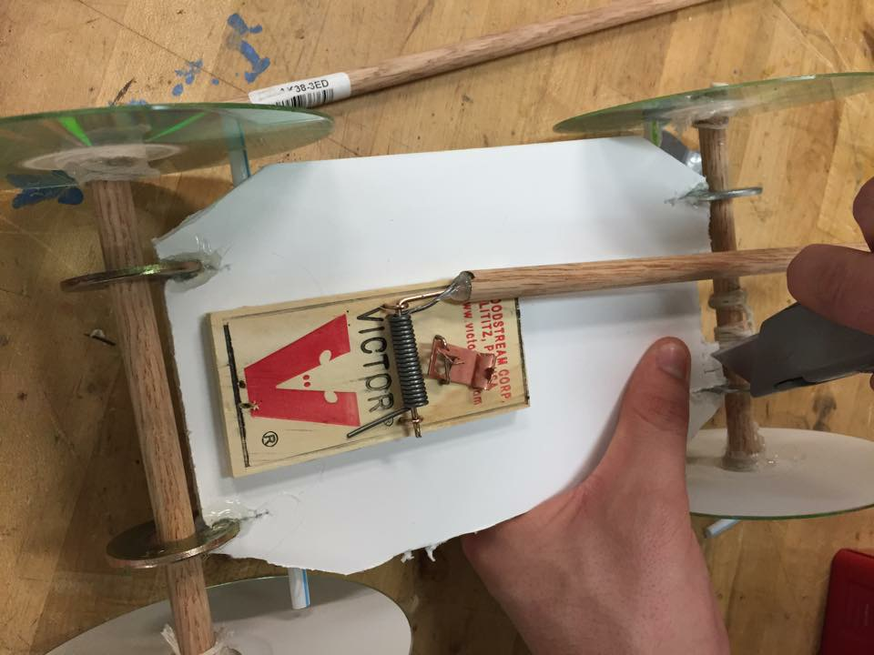

Figure 4: Mousetrap mounted on platform and connecting string

References:

(1) Calibre, bullet series mini fan

(2) Home Depot, wooden dowel

(3) Memorex, 80min CDs

(4) Victor, mousetraps

(Inspiration and Instruction)

While the unique integration of each component into the final product formed an original design, the underlying mechanisms were established well before we decided to put them together. Our main source of guidance was an anonymous Internet article called “mousetrap cars” (Ideas-Inspire, mousetrap cars), written by a mousetrap car enthusiast who outlined not only how to build a mousetrap car, but how to custom tailor it to your specifications. All of these tidbits of advice were supported by scientific explanations of the physical principles at work. From this source, we discovered that it would be ideal to extend the mousetrap’s lever arm such that mechanical advantage would be reduced, and distance traveled therefore increased, at the cost of the force with which the car traveled. The enthusiast also suggested that we accompany very thin wheels with an extended lever arm, because force would be reduced, and as a result, for motion to take place, friction must be reduced to the greatest extent possible. This suggestion ultimately led to our choice of CDs as wheels. A sketch of our design can be seen below in figure 5. As for procedural instructions for the construction of a mousetrap car we used the wiki-how guide online (Wiki How, How to build a mousetrap car). While we toyed with many configurations, and even concepts for how to approach the task at hand, we ultimately settled on a mousetrap car for it’s simplicity and cost effectiveness.

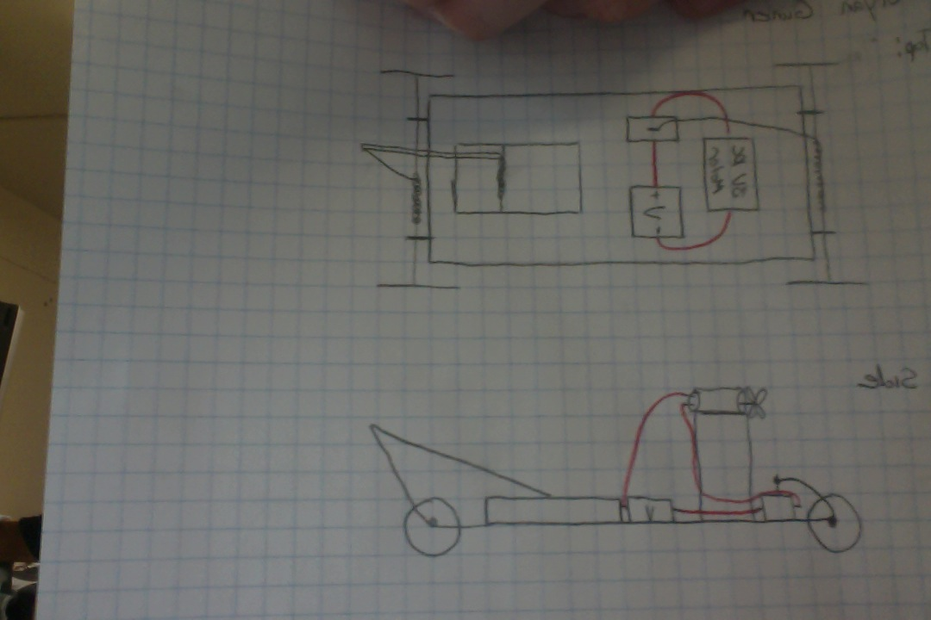

Figure 5;( Sketch of our original mousetrap concept from top and side views, red wires are electrical)

References

1. Ideas-Inspire, Mousetrap Cars , retrieved April 15, 2015, from <http://ideas-inspire.com/mousetrap-cars/>.
2. Wiki How, How to build a mousetrap car , retrieved April 15,2015, from <http://www.wikihow.com/Build-a-Mousetrap-Car>

(Alternative Designs)

While we ultimately settled on a mousetrap car for our fire-extinguishing platform, because of its ease of design and construction, we originally considered many different approaches. Below are outlined the three alternatives we gave the most consideration.

1. One concept we considered, was a speaker system that used controlled sound from a subwoofer rather than air from a fan to extinguish a candle flame. This concept may sound absurd, however, there are many videos of the phenomena at work on the Internet. Unfortunately, this approach was ruled out due to both the complication and expense of utilizing sound technology to put out a fire, not to mention a group-wide lack of the know-how necessary to put this principle to work.
2. Another configuration we considered more seriously was an automated robot, controlled by a preprogrammed micro controller. The idea was to have a chassis on motor driven wheels with a fan and obstruction sensor mounted to the top. We could then program the micro controller to move forward in a straight line until the obstruction sensor detected the candle. At this point the microcontroller would turn off the motors and divert power to the fan in order to extinguish the candle. This approach seemed viable especially because we already possessed the necessary microcontroller, however, our hops were ultimately in vain, as no group members possessed the skill necessary to program the controller.
3. Our most viable alternative worked almost identically to the mousetrap car in that it called for the process to be controlled by mechanical energy stored in a rotating cog. This design was never realized because we could not source or create the cog we had envisioned to store the energy.

(Design Changes during Testing)

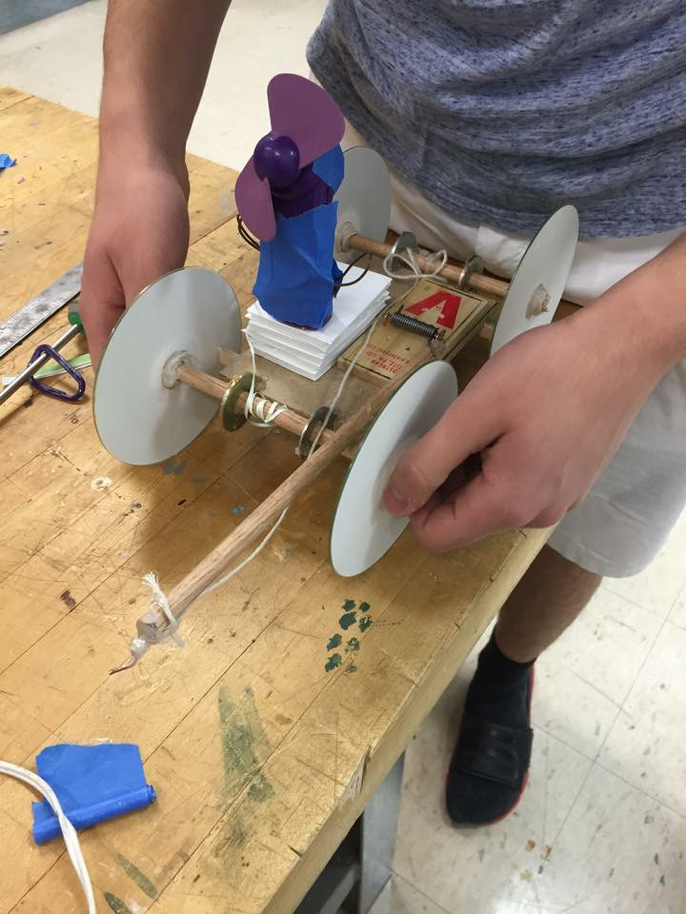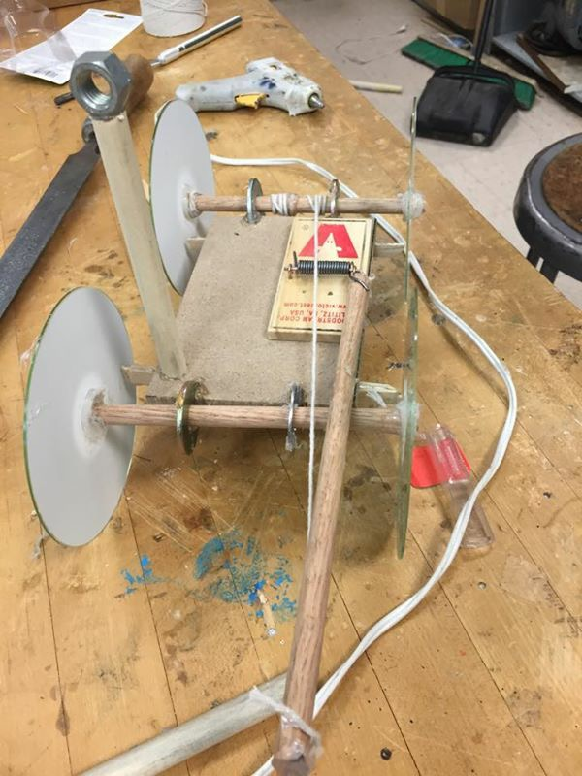Our final design was nearly identical to the original one. The only major differences were, replacing the battery-motor-switch component with a mass-produced mini fan to save time, and attaching the string responsible for breaking/fan activation to an axis rather than to the extended lever arm. Another alteration made during construction, was abandoning the elevated loop responsible for guiding the string attached to the breaking axis(as seen in figure 6) to the fan switch for a more highly sensitive switch attached directly to the breaking axis (figure 7).

Mousetrap car with loop before fan is attached

Figure 7: ( Finished product with altered fan switch and

**Building the Prototype**

**Jamie Lee**

Building the actual final project began after we decided on the many designs we had. The first task was to go out and buy the materials. We had a set materials list, and traveled to Home Depot, Radio Shack, and Staples to retrieve the materials necessary to build the project. After we retrieved all the materials necessary to complete the project, we made our way to the lab, or room 135, and began to brainstorm how we would actually start the project.

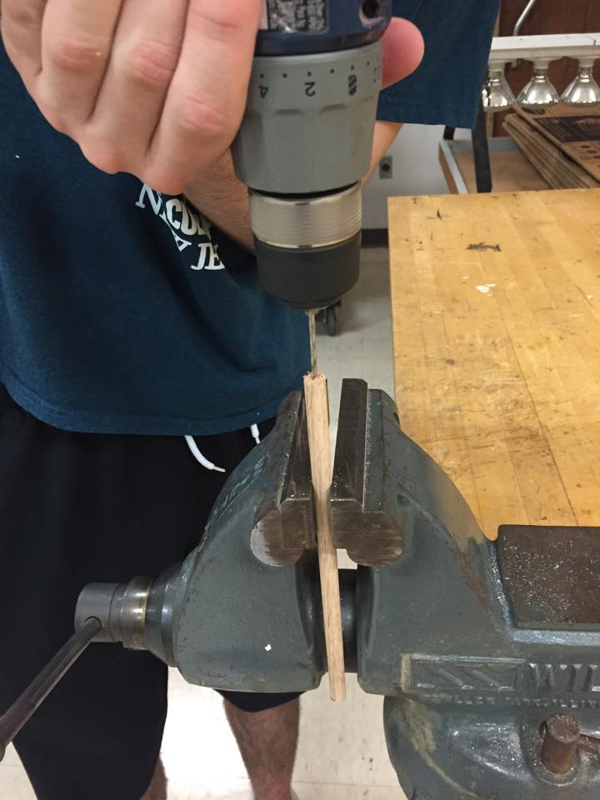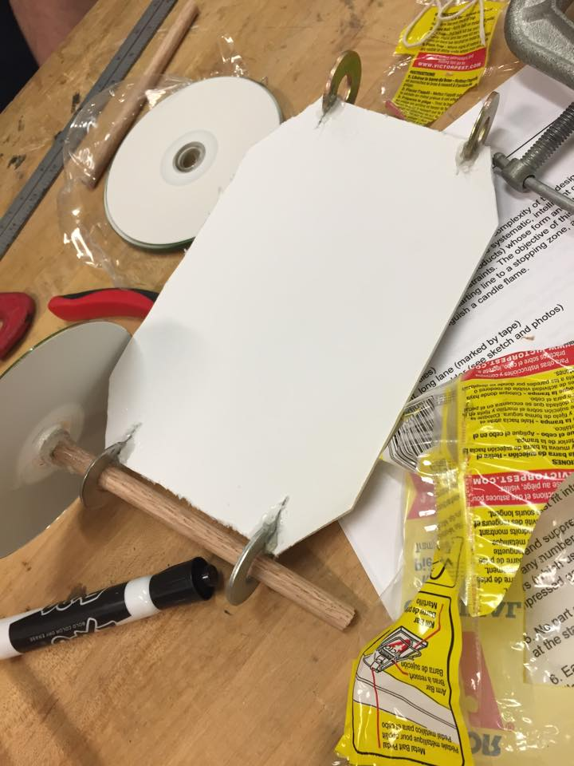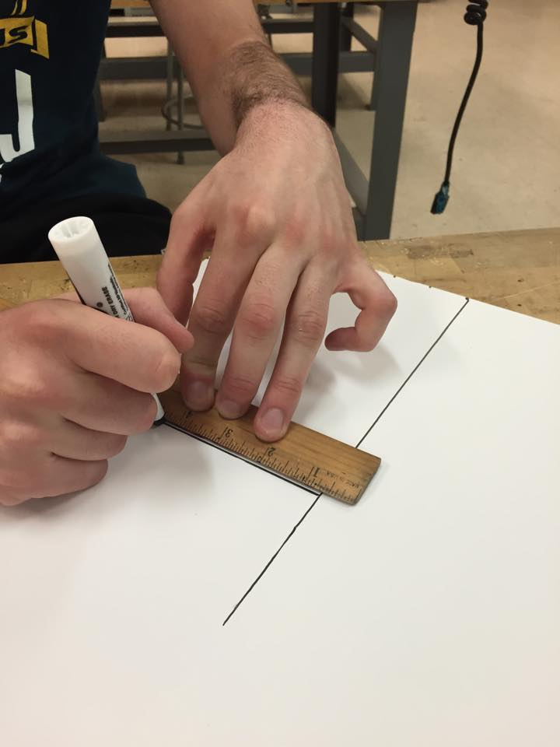 The primary step taken was using a Styrofoam board to use as a base for our mousetrap contraption, and we cut it to 6 inches by 7 inches, to make sure it could fit in the box with larger dimensions. The Styrofoam was then cut with an X-acto knife to ensure precision and clean sides. After the board was cut, we hot glued the mousetrap onto the middle of the board, and waited for it to dry. As the glue dried, we measured out a wooden rod to about 5 inches, and drilled a hole on the top to attach part of the mousetrap onto the rod to power to car to move when the mousetrap is released. Since we cut the top of the metal part of the mousetrap, the vertical piece of metal connected to the spring was inserted into the drilled hole in the rod. We hot glued the metal and the hole together, and waited for that to dry as well. “A set mousetrap is full of potential energy which, when released, is converted to kinetic (motion) energy. The design of your car allowed that energy to be transferred to the axle to make the wheels turn” (Hometrainingtools 1). We then added axels to the car by cutting holes into the ends of the board. The axels were made with washers, and the rods that were also used for attaching the metal and the rod to ignite the kinetic energy needed to make the car move. Then, we added cd’s to the ends of the rod to act as wheels, because the rods themselves turned rather than the cd’s, so we hot glued the cd’s to the ends of the rod and they rolled as the axels rolled. Finally, we attached string the middle of the rods to attach to the initial rod attached to the metal part of the mousetrap, because the tension from the string would allow the car to move from the force. “The Challenge with all mousetrap vehicles is to turn the stored potential energy from a wound up mouse trap's spring into the kinetic energy of motion. The most basic design for propelling a mousetrap racers is to tie one end of a string to a mouse trap's snapper arm and then attach the other end of the string to a drive axle” (Balmer 1). However, the part that constricted the group from finished was the mounting of the fan. The group forgot to bring a fan, and coincidentally, the Styrofoam board ended up breaking for the force exerted by the mousetrap, so we had to start from scratch.

Drilling rods

Adding axels in the board

Measuring the material for the base

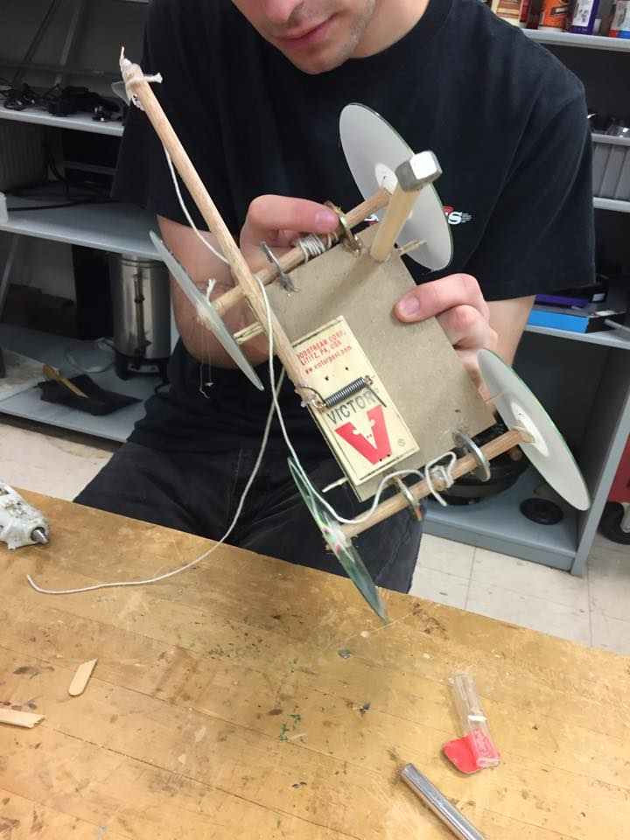Starting the whole project from scratch was very frustrating, because we didn’t know what material to start with. Luckily, we found some wood, a sturdy material that was light enough, but wouldn’t break when we used the mousetrap. We kept the design, and we used the same steps as the Styrofoam board, to build the new wooden based mousetrap car. I assisted with the gluing process, as well as adding a mini part to the axels to keep the rod from moving without restraint. The rods in the axels kept moving, causing the wheels to turn and become uneven, so the little parts added right next to the wheels aided to control the wheels. Finally, the mousetrap car was done, but without the fan. Building the actual car was a team effort, everyone helped add things to the car, but my contribution was aiding in the physical labor aspect of the car, but everyone also aided with the physical labor. When the fan was finally added, the car ended up not working again, and the group was not ready to move on because we didn’t know what to do, but luckily for Dr. Asper, the car was revived.

Reattaching the mousetrap

**References**

Balmer, Alden J. "Mousetrap Car Design Basics." *How to Build a Mousetrap Car*. N.p., 23 Jan. 2012. Web. 01 May 2015

"Mousetrap-Powered Car." *Build a*. N.p., n.d. Web. 01 May 2015.

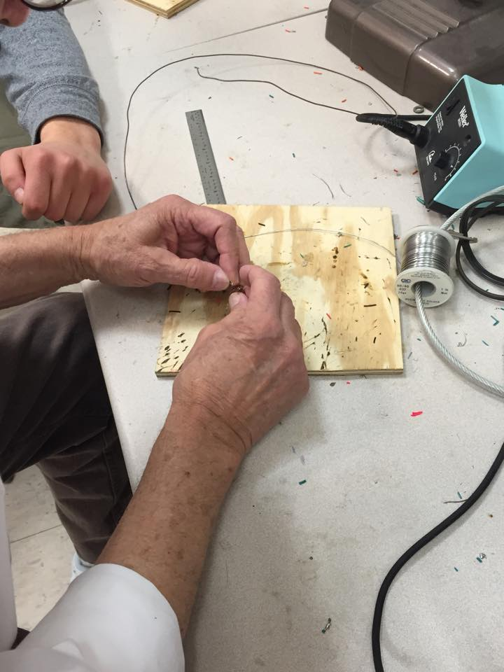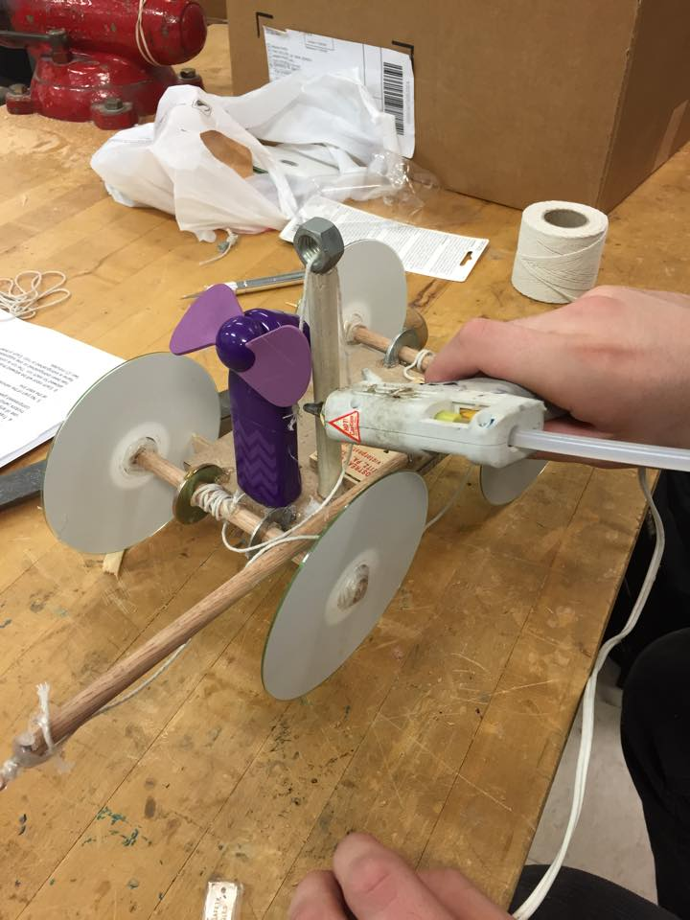During the process of building the framework for the fire extinguishing robot, our team constructed a wooden base that was attached to four CD ROMs being utilized as wheels, also on the base of the structure was a mouse trap attached to a rod that was tied with string. Our group ran multiple test runs to see if the force of the mouse trap moving against the rod would create mechanical energy in order to move the robot forward ten feet. After conducting the tests we concluded that the robot could fully stop at the distance requirement of ten feet, but our next task was to figure out a way to put out the candle after the robot comes to a full and complete stop. After contemplating making our own fan we decided to use a small store bought fan to put out the candle at the end of the ten feet. As seen in *Figure 1* our original idea was to mount the fan in front of the mouse trap and glue string that was attached to the rod onto the switch that turned on the fan. We were hoping that when the rod exerted force on the string that it would pull on the switch which activated the fan, but unfortunately it was a failed trial. Our next solution was to take apart the fan and solder two wires to the battery receptors inside the framework of the fan and then we glued a switch to the base of the robot. As seen in *Figure 2*, 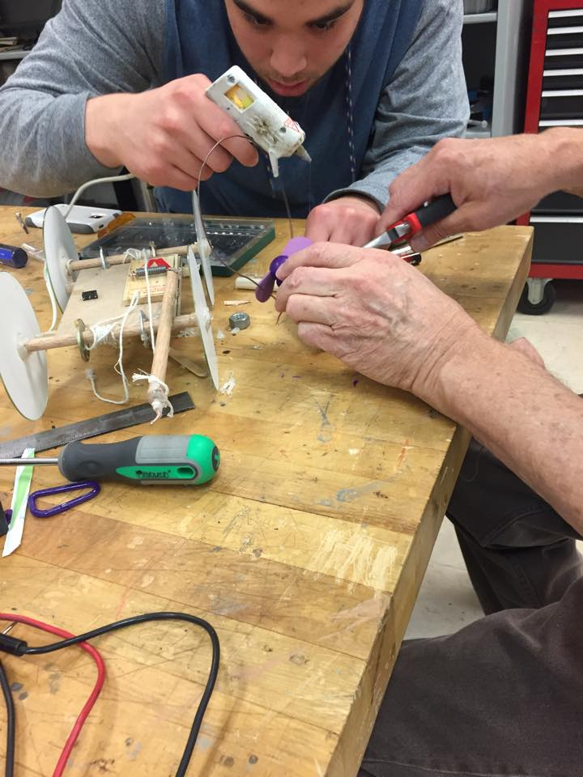with the help of Dr. Asper the wires were soldered onto the battery receptors. As pictured in *Figure 3*, we glued the receptors down to the framework of the fan in order for the batteries to be placed inside the fan. Shortly after we stripped the ends of the wires and touched the ends together to make sure the fan blades began to spin. When we confirmed the blades spun after touching the stripped ends together we then glued a switch to the base of the robot frame and then glued the finished fan in front of the mouse trap on top of elevated Styrofoam in order for the fan to blow out the candle at a height of twelve inches. Our group also taped around the entire fan to assure the wires didn’t interfere or become damage due to the testing process. We then used the soldering iron to connect the front 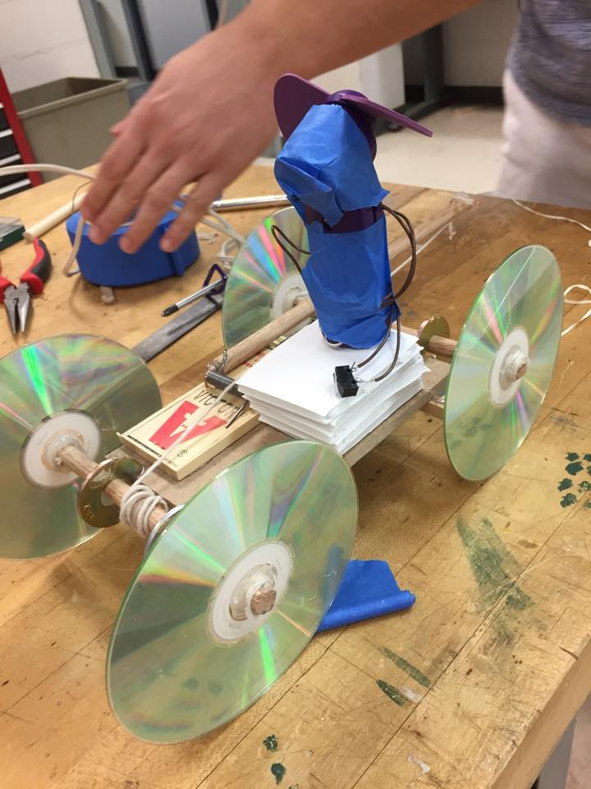of the switch to the ends of the wires in order to produce a current of energy that was needed to propel the robot forward. We then tied dental floss around the back of the switch and wrapped it around the axel of the wheels so that when the robot came to halt the pressure from the string pulls the switch and causes the fan to activate. As depicted in *Figure 4* the final product completed the requirements and stopped at ten feet and successfully blew out a candle flame.

*Figure 2*

*Dr. Asper helping our group solder the wires to the battery receptors*

***Wiring and the Finished Product***

*Figure 1*

*Gluing the string to the switch on the fan*

*Figure 3*

*Mike gluing the battery receptors to the frame of the fan while Dr. Asper clamped the receptors in place.*

*Figure 4*

*The finished Fire Extinguishing Robot*